This or That Menu! Grades K-2
Sight Word, Phonics & Fluency Practice | I Can Read to Self and Think About My Reading | I Can Write! | I Can Show Stamina!
I can rainbow write my words for the week on a piece of paper, outside with chalk or use my art supplies.  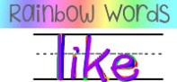 | I can read my book to my family, friends or stuffed animals and talk about the pictures. | I can write to my teacher about my day, a book I’ve read or a video I’ve watched. I can edit it to make sure that I have complete sentences and capital letters. | I can read for more than 20 minutes!  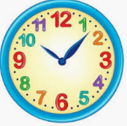
I can write my spelling words in a sentence or story!   | I can record myself reading and send it to my teacher or post it on SeeSaw.   | I can write or draw about a story I’ve read, a favorite character, or scene. I can even add a lot of details! | I can write a story with a beginning, middle, and end and read it to a family member, friend or stuffed animal.
I can practice letter sounds/ sight words using an app at home! (see Parent Resources)  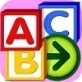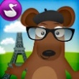 | I can read or listen to a book on Epic, TumbleBooks or StoryLine online.   | I can write a list of things in my house, things I see outside, or things that I like to do, or even create a shopping list. | I can learn about a topic and take a quiz on BrainPop!  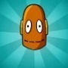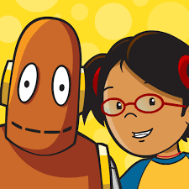
I can play a game with my sight words:  Three Cards Down (see Parent Resources)  Memory  Hang Man  Tic-Tac-Toe | After reading a story, I can fill out a character trait map (see Parent Resources) or a story map to help me think about what I’ve read. | I can write a letter to my friend or teacher about facts I learned or questions I have after reading a nonfiction book or article.  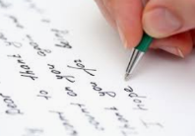 | I can write as many words as I know how to spell on my own. I can read my list to an adult or friend.
Look through one of your books and see how many of your sight words you can find. Tally up how many you find:  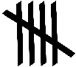  Can you find digraphs, vowel teams or other word patterns? Try coding them! | I can retell the story I’ve read to someone, being sure to include the characters, setting, beginning, middle, end, problem and solution.  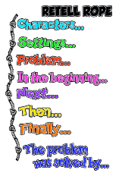 | I can write 3 questions about my story/passage. Then I can record where I found the answers in the text:  page ____ | When I am reading, and I get stuck on a word, I do not give up. I can...  Look at the picture  Make the beginning sound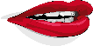  Think about what makes  sense  Look for parts I know  split
I can make words with my Fundations letters (K,1st). I can sort my words from Word Their Way (2nd) | After reading a nonfiction text, I can list the facts I’ve learned or write them in a journal. | I can write down questions I have about a story before, during and after I read. | I can reread a story to practice my fluency. I record my reading on SeeSaw.
I can read my Phonics Word Chunks as fluently as I can in one minute. (see Parent Resources.) | I can complete a book rating or recommendation (see Parent Resources) for a book I’ve read. I can add a drawing, too! | I can write a poem using one or more of my sight words. | I can spend time free writing on a topic of my choice. I can get all my ideas down on paper! Drawing pictures first always helps!

This or That Menu! Grades 3-6
Vocabulary and Fluency Practice | I Can Independently Read and Think About My Reading | I Can Independently Write and Reflect on My Writing | I Can Show Stamina and Grit.
I can write each of my vocabulary words and their definitions using a dictionary or online resource. | I can read a story or chapter of my book and retell it to a family member. I can even create a video! | I can write an email to my teacher about my day, a book I read or a video that I watched. | I can read for more than 30 minutes!
I can write my spelling words in a sentence, story or poem and then share it with a friend, family member or fluffy friend. | I can record myself reading and send it to my teacher or post it on SeeSaw.   | I can write a story/poem about...  I will be sure to include character(s), setting, problem, solution. | I can write a story with chapters/dialogue or a play with multiple scenes.
I can practice vocabulary words using an app at home like Quizlet, Spelling City or Clever.  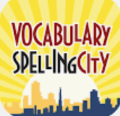 | I can read/listen to a book on Epic, TumbleBooks or StoryLine online.   | I can write a persuasive letter to my parents, teacher or to my favorite restaurant/store hoping they will take my suggestions. | I can learn about a topic and take a quiz on BrainPop!
I can put my vocabulary words on index cards or small pieces of paper and play a game with them. (See Parent Resources for a gameboard).  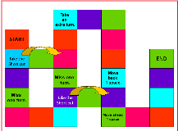 | I can read an article from the newspaper, a magazine or ReadWorks and highlight words I don’t know and then replace those words with other words that make sense. | I can complete a book rating or recommendation for a book I’ve read. (See Book Recommendation Form located for your grade level)   | I can underline/highlight important text evidence that helps me answer my questions.  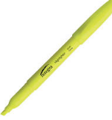
Using my vocabulary words, I can draw a picture with labels. | I can read a chapter in my book and share my thoughts about the characters, the setting or the theme. I like to read with my pencil in hand! | I can write a response, essay or TDA for a text I’ve read. (Organizer can be found on your grade level link) | I can use test-taking strategies when answering multiple choice questions: Slash the Trash!  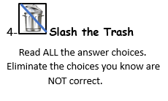
I can use two new vocabulary words throughout the day when talking with my family.  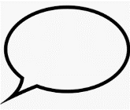 | I can read an article and put my thinking down while reading. I will share the most important ideas and details to support it. | 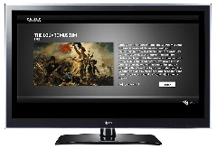  I can watch a non-fiction T.V. show and write about what I learned in a journal. | I can read a longer text and write more than 5 stop and jots to help me better understand what I’ve read.
I can record the definition, a synonym/antonym and illustrate each of my vocabulary words. | I can read my book or article and share a summary of the text.  Somebody, Wanted, But, So, Then  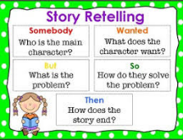 | I can write an acrostic poem using adjectives to describe my topic.  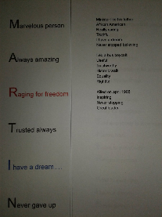 | After reading a nonfiction text, I can create a PowerPoint, a commercial or poster highlighting the main ideas and most important details.  